Trigonometric Identities and Equations- MS

June 2019 Mathematics Advanced Paper 1: Pure Mathematics 1

|  |
| --- |
|  |
|  |

June 2018 Mathematics Advanced Paper 1: Pure Mathematics 1



May 2019 Mathematics Advanced Paper 1: Pure Mathematics 1

May 2018 Mathematics Advanced Paper 1: Pure Mathematics 1

May 2017 Mathematics Advanced Paper 1: Pure Mathematics 2

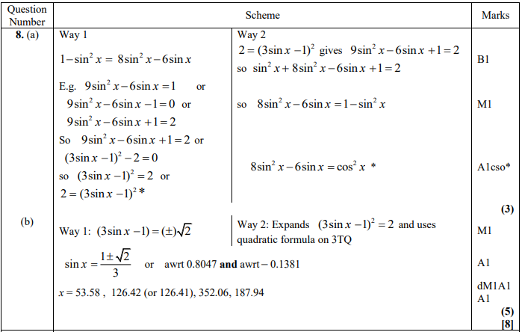

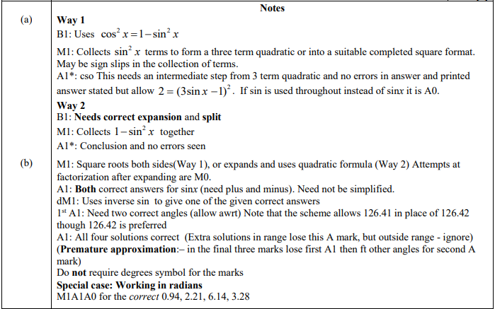

May 2016 Mathematics Advanced Paper 1: Pure Mathematics 2

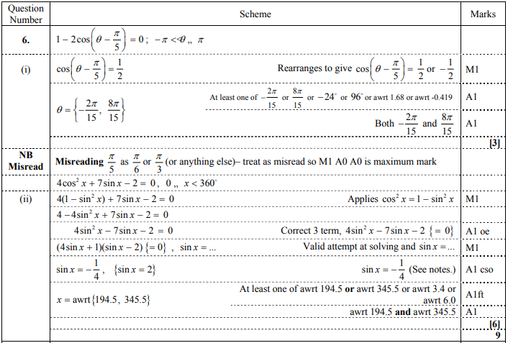

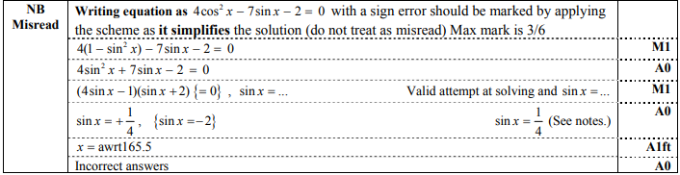

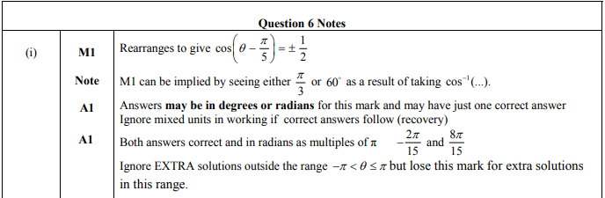

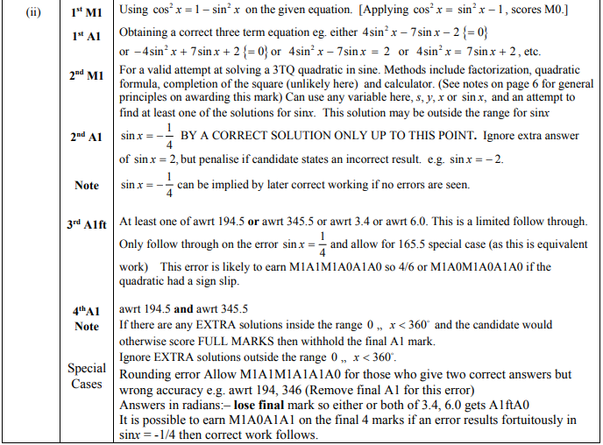

May 2015 Mathematics Advanced Paper 1: Pure Mathematics 2

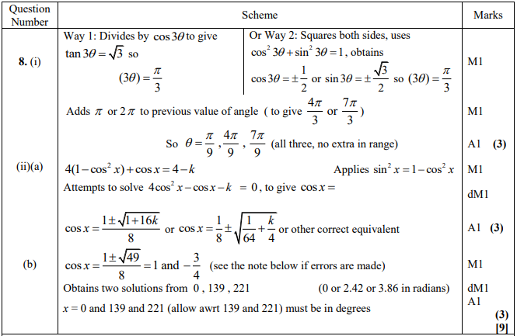

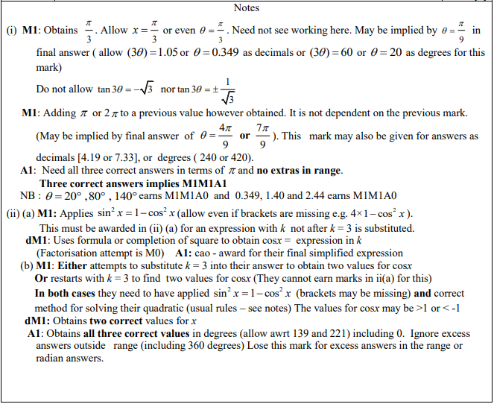

May 2013 Mathematics Advanced Paper 1: Pure Mathematics 2

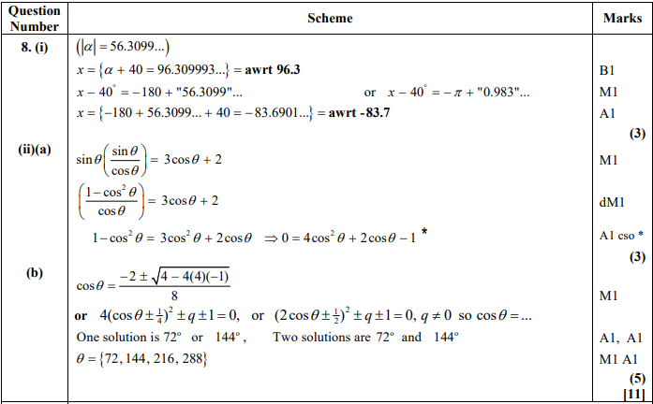

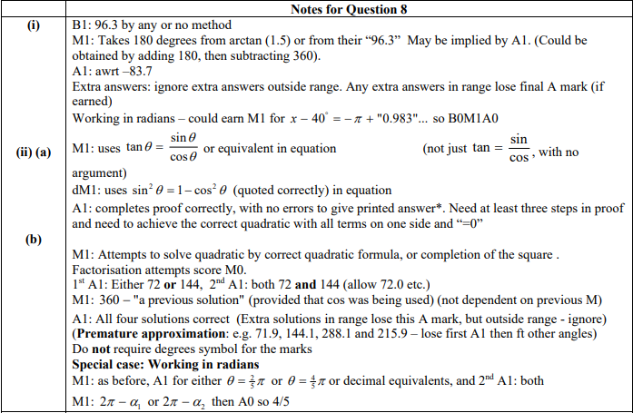

Jan 2013 Mathematics Advanced Paper 1: Pure Mathematics 2

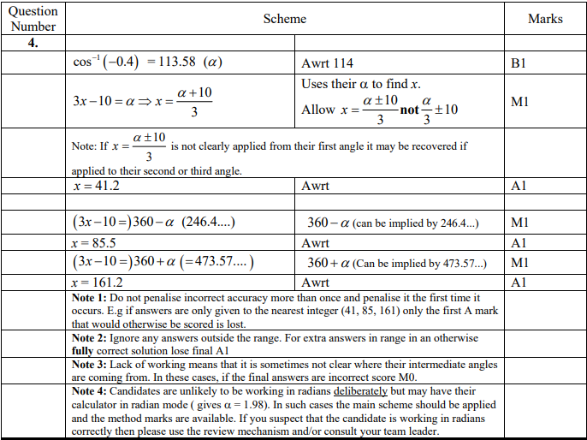

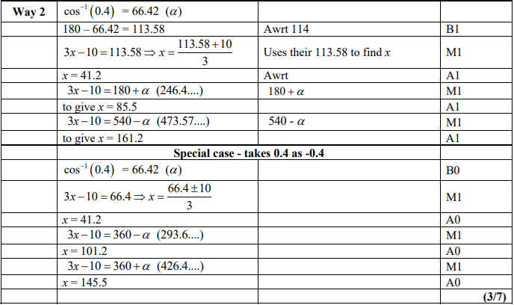

May 2012 Mathematics Advanced Paper 1: Pure Mathematics 2

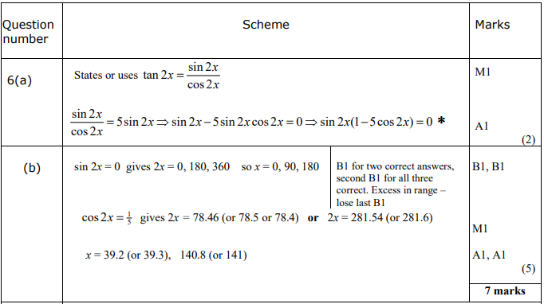

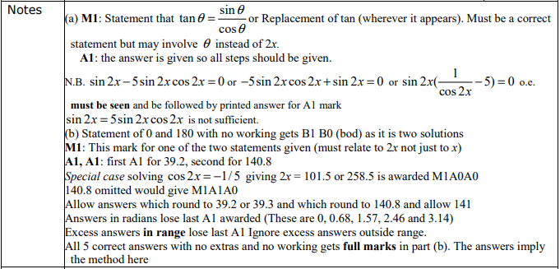

Jan 2012 Mathematics Advanced Paper 1: Pure Mathematics 2

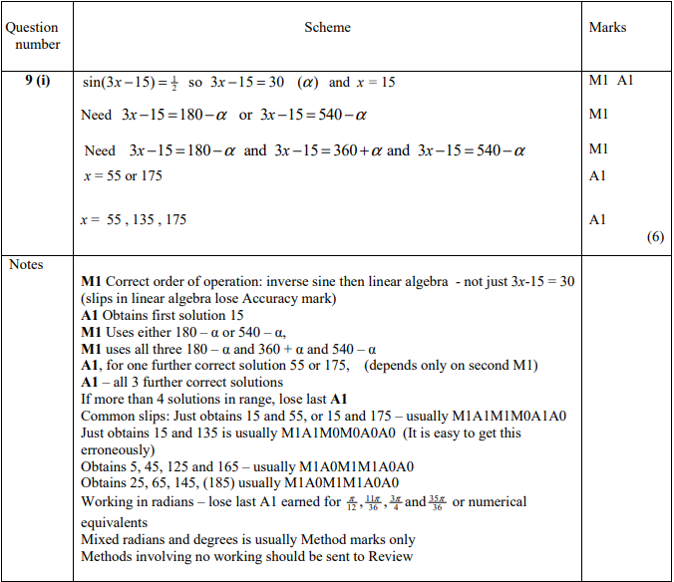

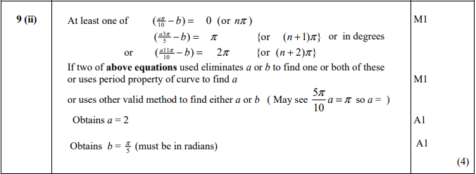

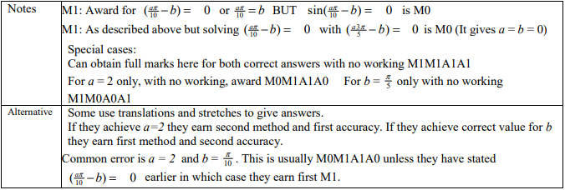

May 2011 Mathematics Advanced Paper 1: Pure Mathematics 2

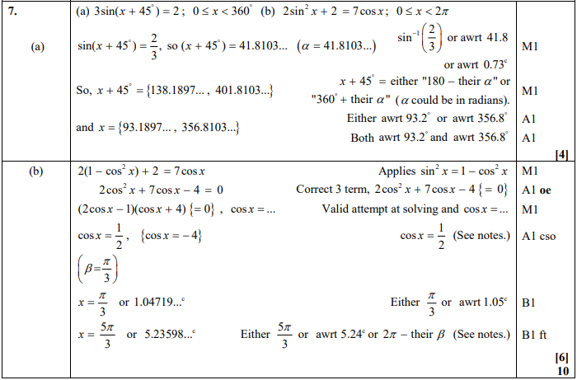

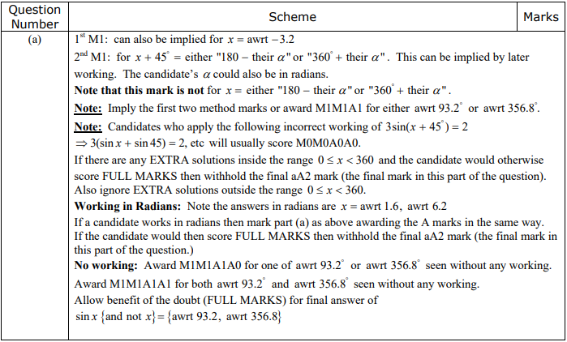

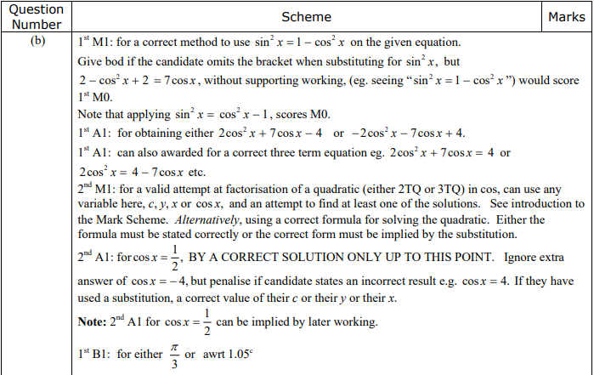

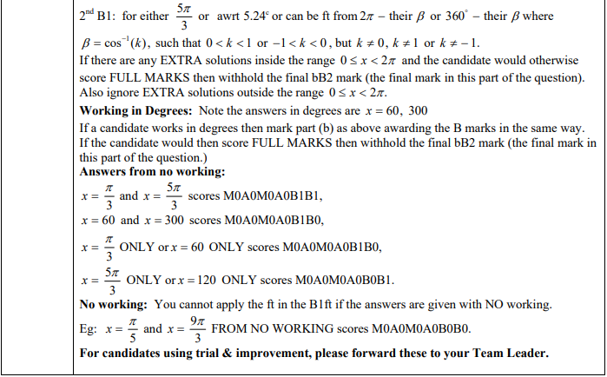

Jan 2011 Mathematics Advanced Paper 1: Pure Mathematics 2

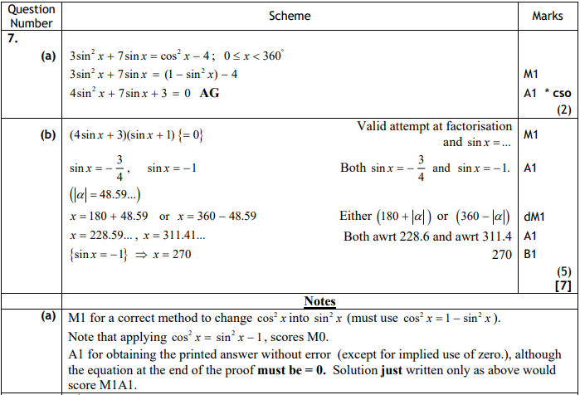

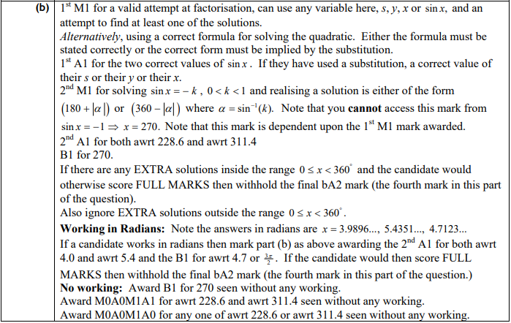

Jun 2010 Mathematics Advanced Paper 1: Pure Mathematics 2

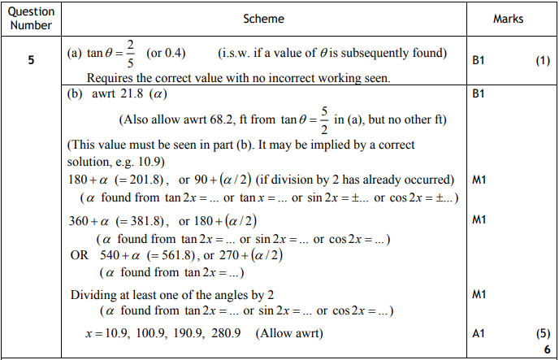

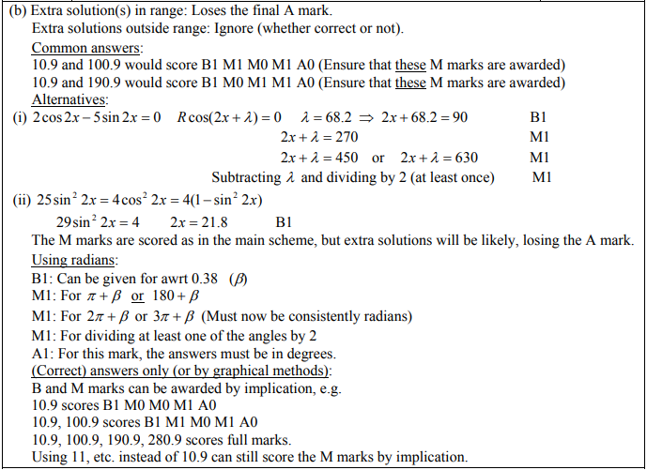

Jan 2010 Mathematics Advanced Paper 1: Pure Mathematics 2

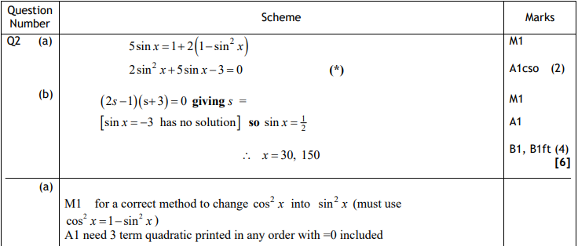

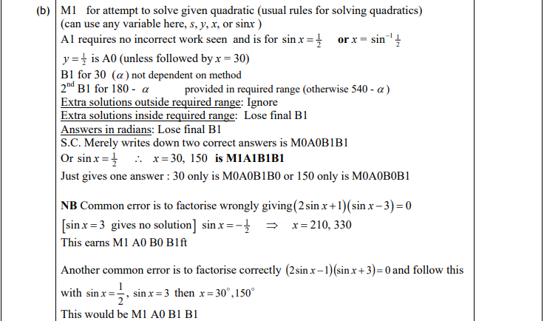



June 2013 Mathematics Advanced Paper 1: Pure Mathematics 3

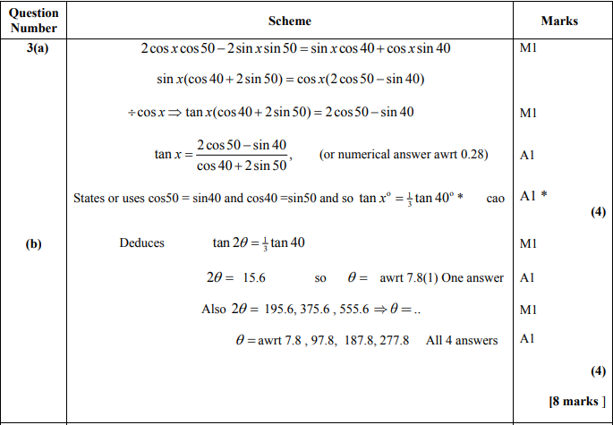

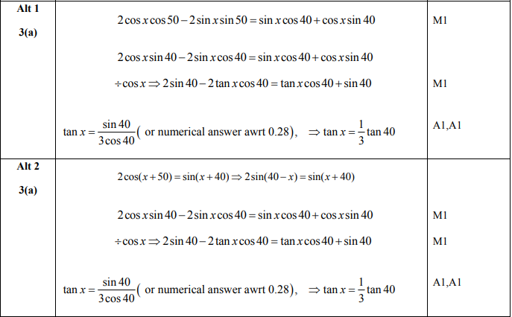

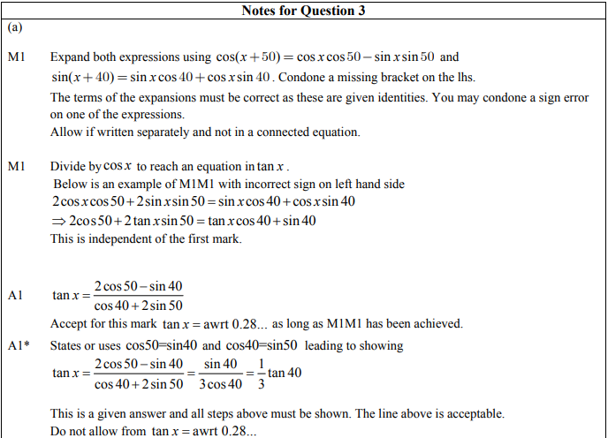

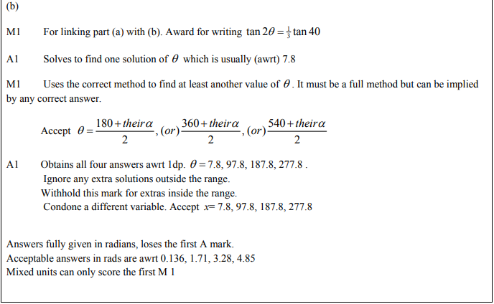

Jan 2011 Mathematics Advanced Paper 1: Pure Mathematics 3

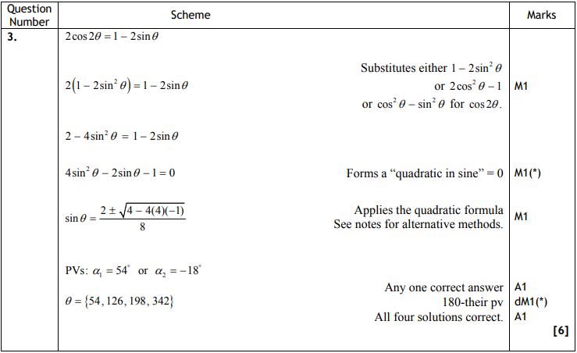

June 2010 Mathematics Advanced Paper 1: Pure Mathematics 3

